**All Tables created under Public Schema**

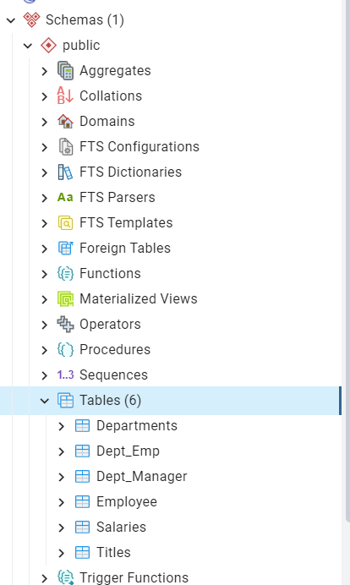

**Query1:**

SELECT Emp."Emp_No" AS Employee_Number,"Last_Name","First_Name","Sex","Salary"

--Emp."Emp_no" AS Employee_Number, Emp."last_name", Emp."first_name", Emp."sex"

FROM public."Employee" Emp

Inner Join public."Salaries" Sal

ON Emp."Emp_No" = Sal."Emp_No"

limit 10;

**Result1:**

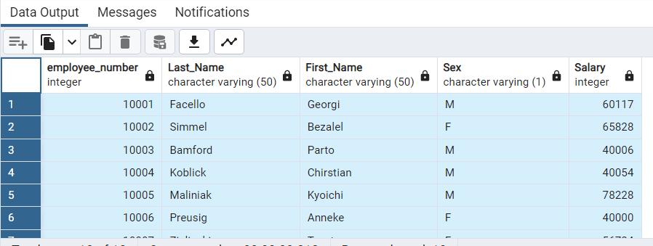

**Query 2:**

SELECT Emp."Emp_No" AS Employee_Number,"Last_Name","First_Name","Sex","Salary"

--Emp."Emp_no" AS Employee_Number, Emp."last_name", Emp."first_name", Emp."sex"

FROM public."Employee" Emp

Inner Join public."Salaries" Sal

ON Emp."Emp_No" = Sal."Emp_No"

limit 10;

**Result 2:**

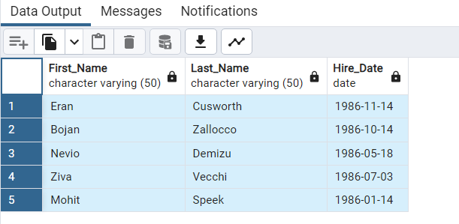

**Query 3:**

SELECT Mgr."Dept_No", Dep."Dept_Name", Mgr."Emp_No", Emp."Last_Name",Emp."First_Name"

From public."Dept_Manager" Mgr

Join public."Employee" Emp

ON Mgr."Emp_No" = Emp."Emp_No"

Join public."Departments" Dep

ON Mgr."Dept_No" = Dep."Dept_No"

limit (5);

**Result 3:**

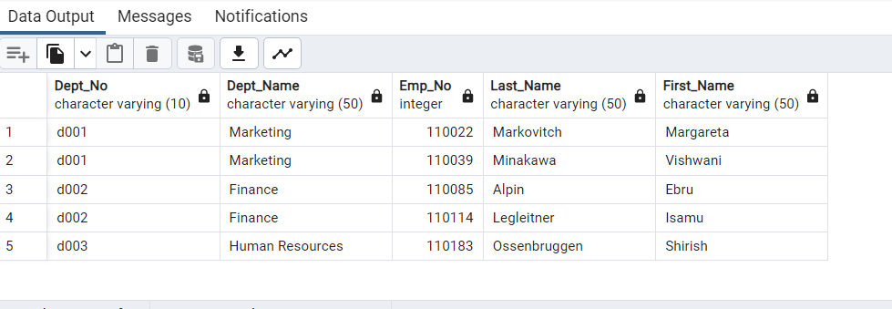

**Query 4:**

SELECT Dep."Dept_No",Emp."Emp_No" as "Employee Number", Emp."Last_Name",Emp."First_Name", Dep."Dept_Name"

From public."Dept_Emp" DEmp

Join public."Employee" Emp

ON DEmp."Emp_No" = Emp."Emp_No"

Join public."Departments" Dep

ON DEmp."Dept_No" = Dep."Dept_No"

limit (5);

**Result 4:**

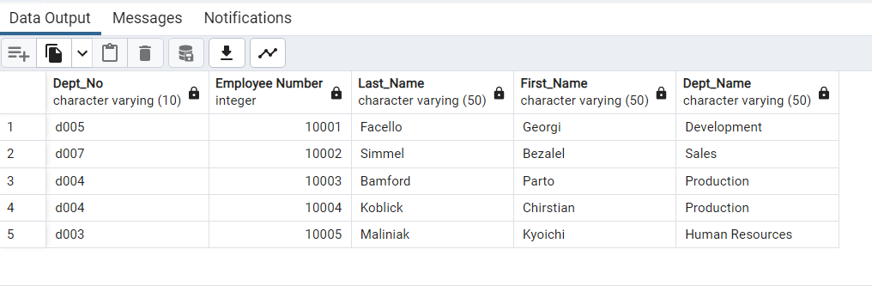

**Query 5:**

SELECT "First_Name","Last_Name","Sex"

FROM public."Employee"

WHERE "First_Name" = 'Hercules'

AND "Last_Name" LIKE 'B%';

**Result 5:**

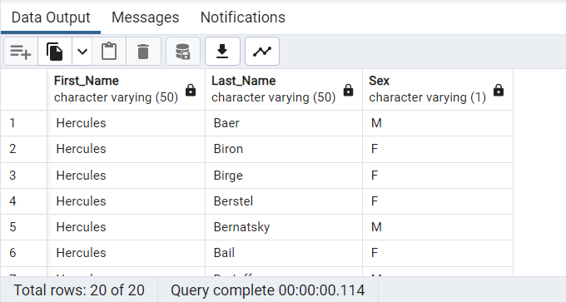

**Query 6:**

SELECT DEmp."Emp_No", Emp."Last_Name", Emp."First_Name", Dep."Dept_Name"

FROM public."Dept_Emp" DEmp

INNER JOIN public."Employee" Emp

ON DEmp."Emp_No" = Emp."Emp_No"

INNER JOIN public."Departments" Dep

ON Dep."Dept_No" = DEmp."Dept_No"

WHERE Dep."Dept_Name" = 'Sales';

**Result 6:**

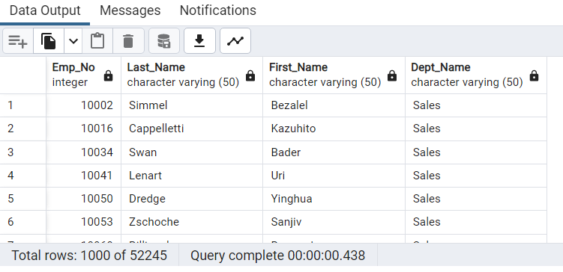

**Query 7:**

SELECT DEmp."Emp_No", Emp."Last_Name", Emp."First_Name", Dep."Dept_Name"

FROM public."Dept_Emp" DEmp

INNER JOIN public."Employee" Emp

ON DEmp."Emp_No" = Emp."Emp_No"

INNER JOIN public."Departments" Dep

ON Dep."Dept_No" = DEmp."Dept_No"

WHERE Dep."Dept_Name" = 'Sales'

OR Dep."Dept_Name" = 'Development';

**Result 7:**

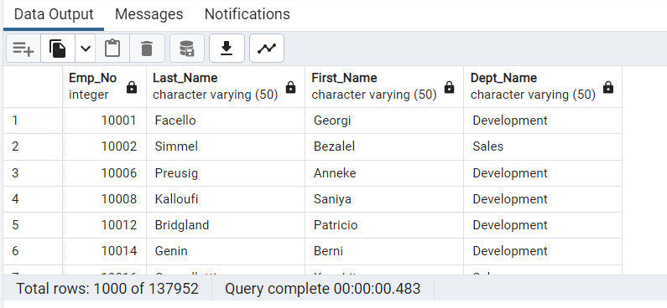

**Query 8:**

SELECT "Last_Name",

count("Last_Name") AS frequency

FROM public."Employee"

GROUP BY "Last_Name"

ORDER BY

COUNT("Last_Name") DESC;

**Result 8:**

